Assignment: Extraction features from Biodata

# PART 1

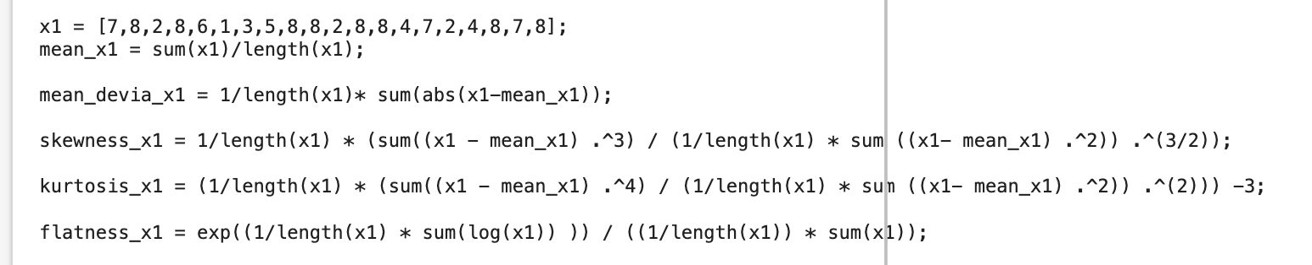I used matlab as a calculator for all questions.

1. Mean = 5.7
2. Mean deviation = 2.26
3. Skewness = -0.5870
4. Kurtosis = -1.2461
5. Flatness = 0.8614

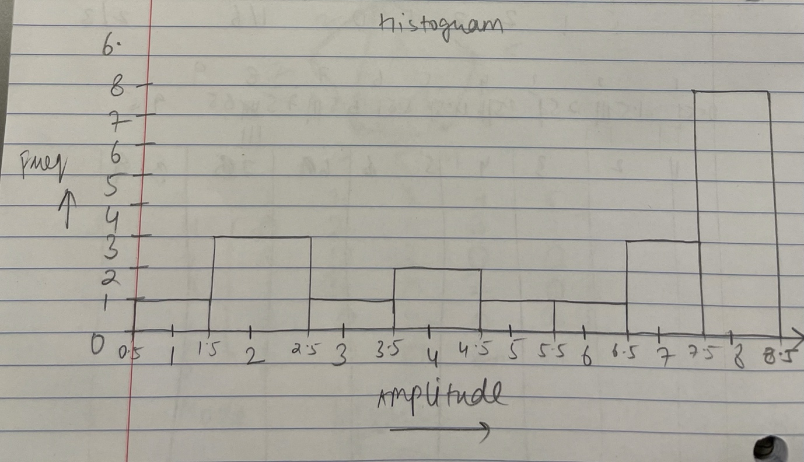

1. I made a method corr_cal(x1,y1) which was called to solve this question:   
   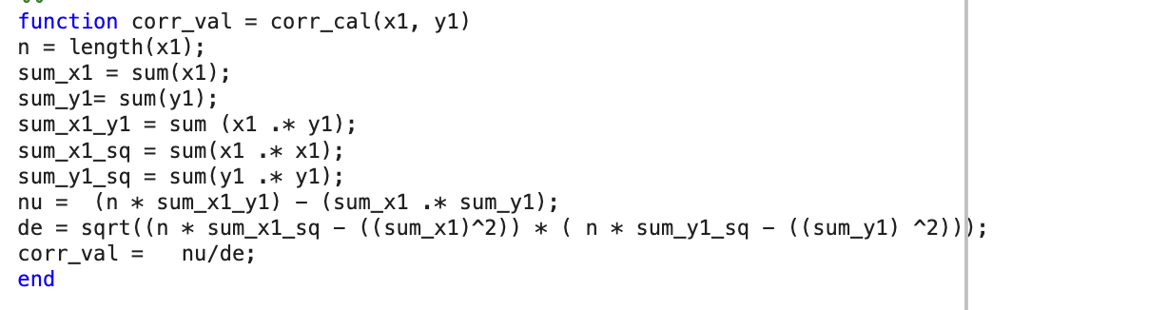
2. x1_delayed_0 = x1

corr_cal(x1,x1_delayed_0) = 1

1. 

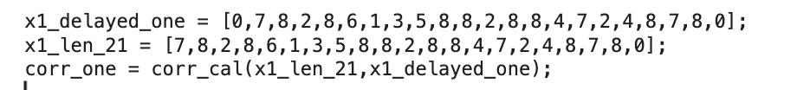 corr_minus_one = -0.1736

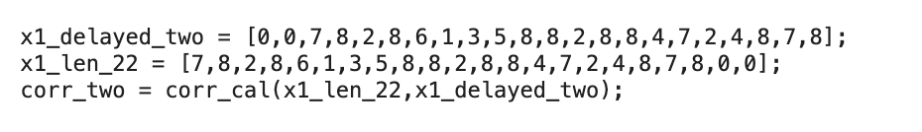 corr_one = -0.2118



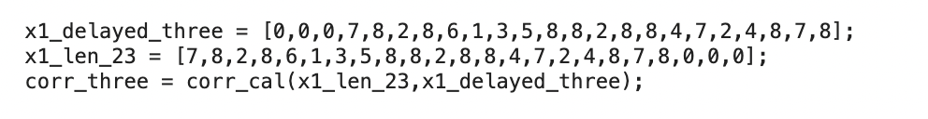corr_two = -0.42410



corr_three = -0.1772

PART TWO

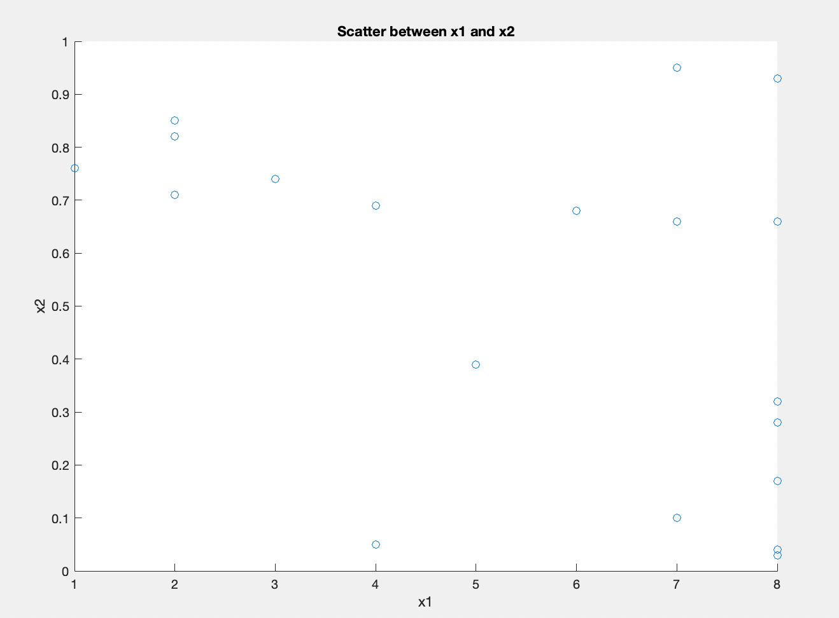

1. A.

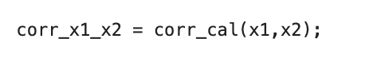B. Same method used as above.

Corr_x1_x2 = -0.482271

C. x1_r =

[11, 16.5,3,16.5,9,1,5, 8, 16.5, 16.5, 3, 16.5,16.5,6.5, 11,3,6.5,16.5,11,16.5]

X2_r =

[10.5,3,18,19,12,16,15,9,10.5,6,14,1.5,7,4,5,17,13,8,20,1.5]

corr_x1_r_x2_r = corr_cal(x1_r, x2_r);

corr_x1r_x2_r = -0.5520

D. x2_delayed_0 = x2

corr_x1_x2_delayed_0 = -0.482271

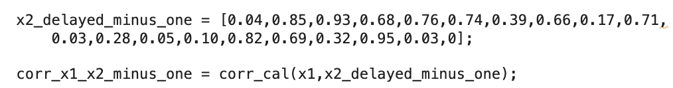

corr_x1_x2_minus_one = -0.1144

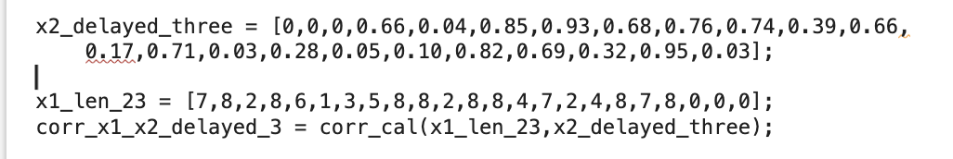

corr_x1_x2_delayed_3 = -0.042589074041333

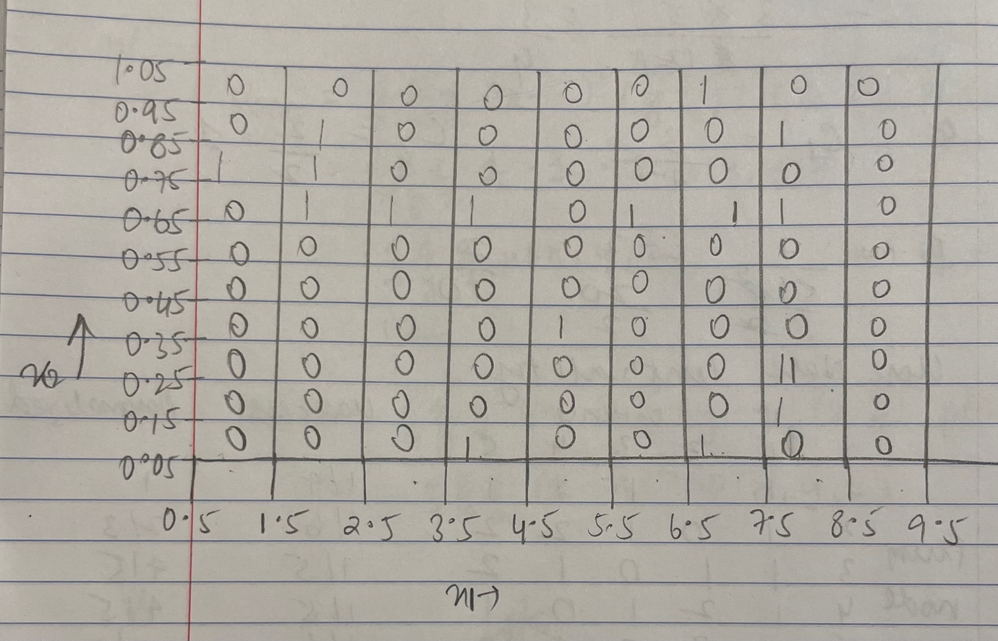

PART 3

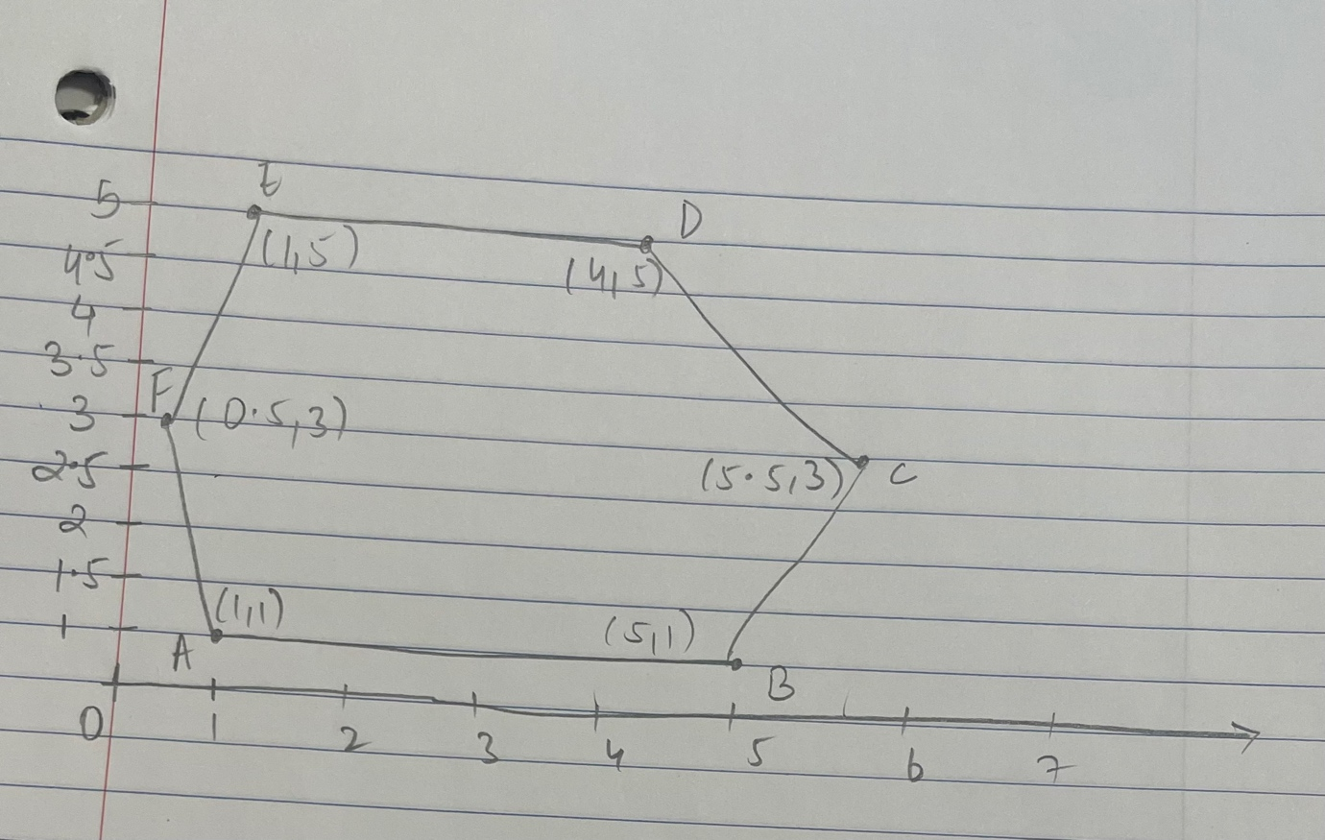

1. 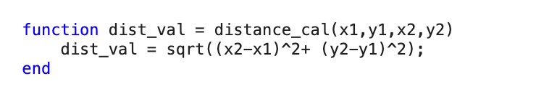I made a method to calculate distance between 2 points.

To calculate perimeter I ran a loop over the arrays to find the length of each side and then added those lengths up.

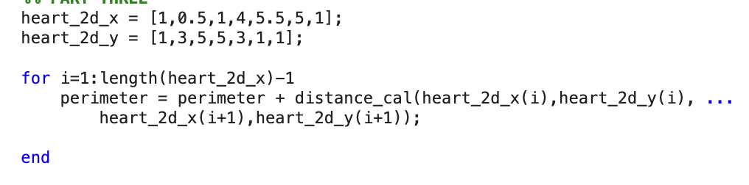

perimeter = 15.684658438426492

1. Area :

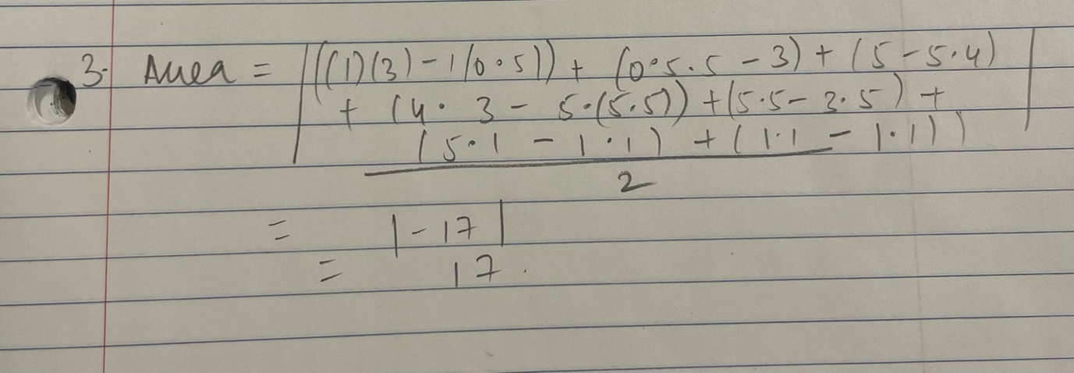

1. I used the same distance method here.

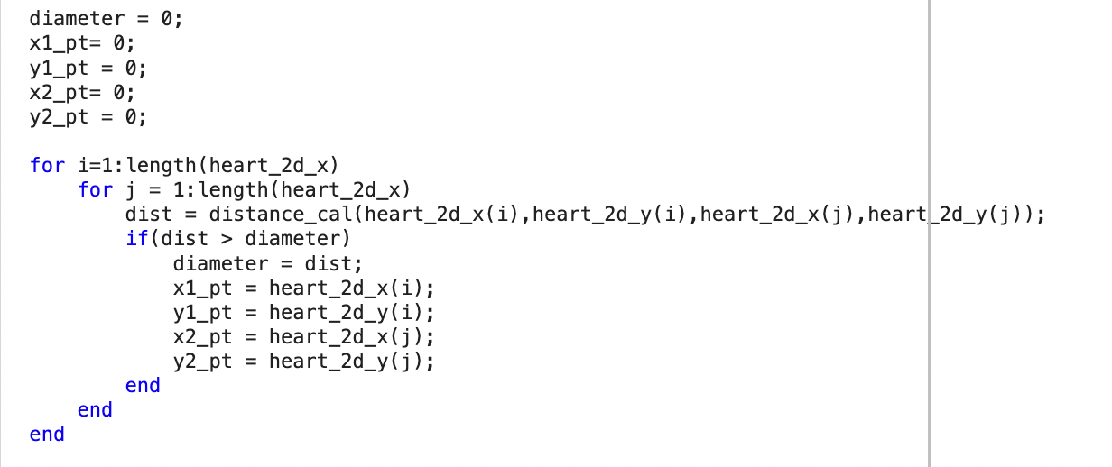I have 2 nested loops to go over each combination of vertices (sides) and then did a comparison operation to find the longest one.

Diameter = 5.656854249492381 (from (1,5) to (5,1))

1. The second longest cord that is perpendicular to the diameter is the cord from (4,5) to (1,1)

Therefore ,



cordB = 5



Eccentricity = 1.131370849898476

1. Compactness = perimeter^2/area = 14.471088842947257
2. 

Centroid = [2.571428571428572,2.714285714285714]

1. I made a method to calculate the angle between the centroid and all the points and the slope of lines.l

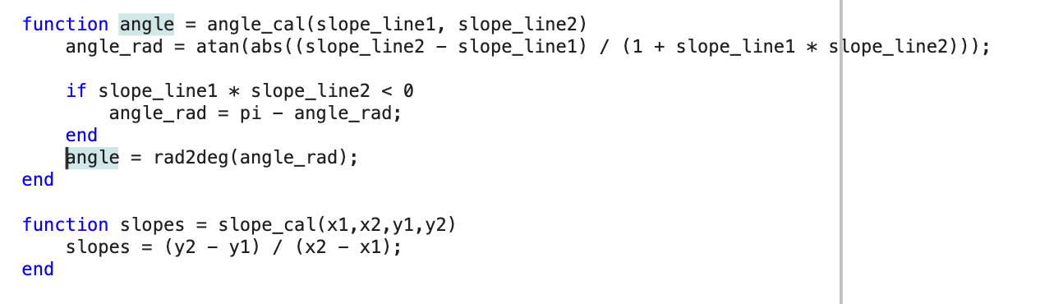

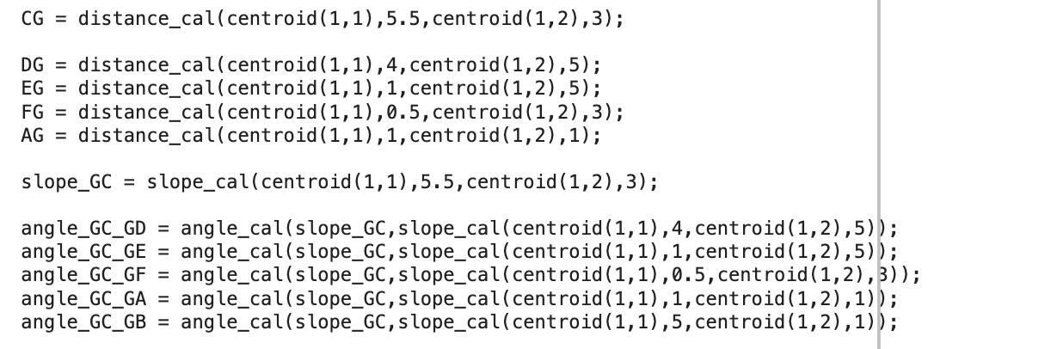

I find the angle that the line GC forms with each of the other points and I get:

angle_GC_GD = 52.422418987952720

angle_GC_GE = 118.9363251837

angle_GC_GF = 166.5744888

angle_GC_GA = 138.0826

angle_GC_GB = 139.2102

DG = 1.010152544552211

EG = 4.002550207463400

FG = 2.504078306136872

AG = 0.142857142857143

CG = 2.504078306136872

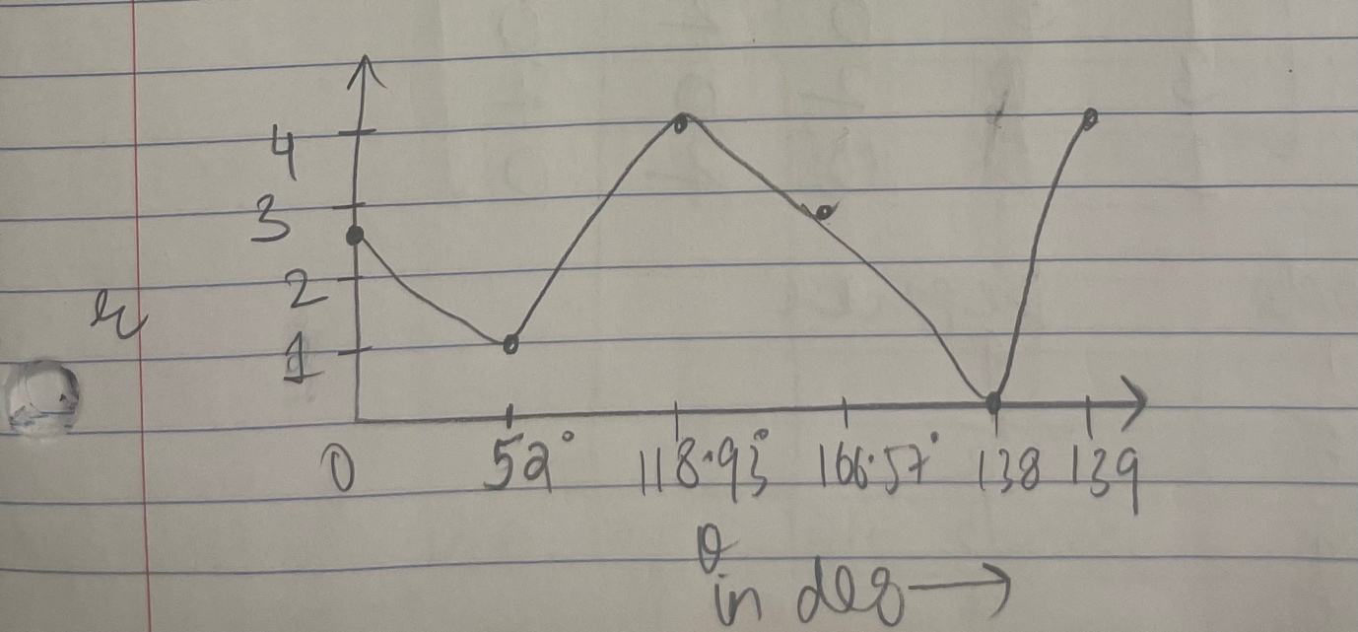

PART 4

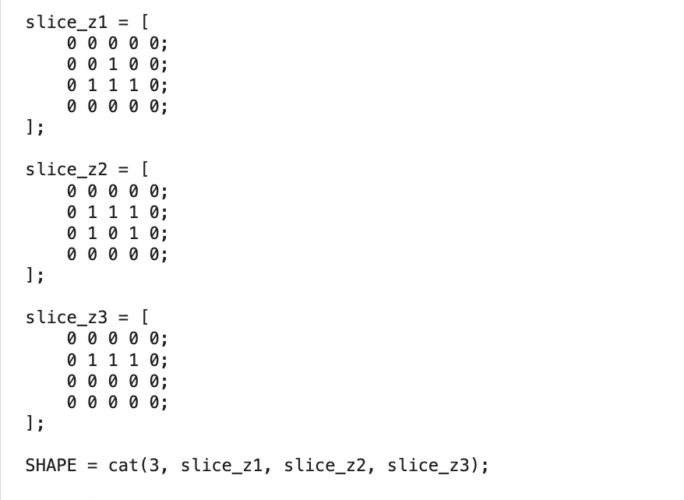

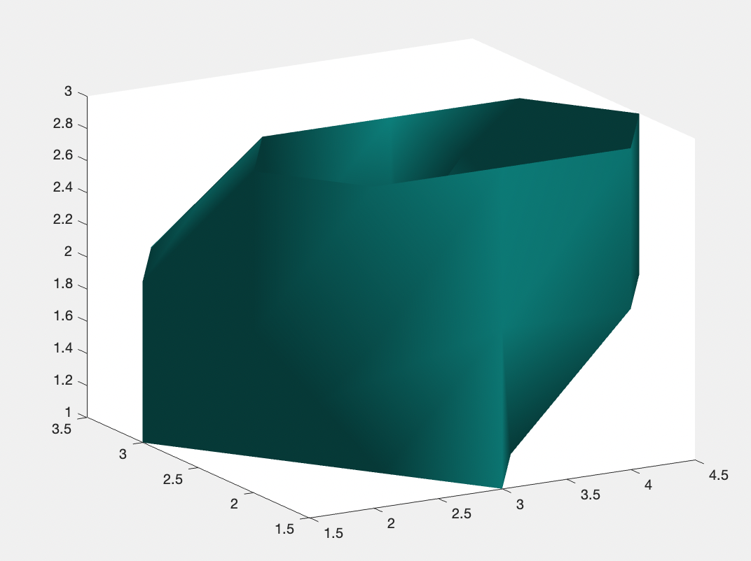

1. 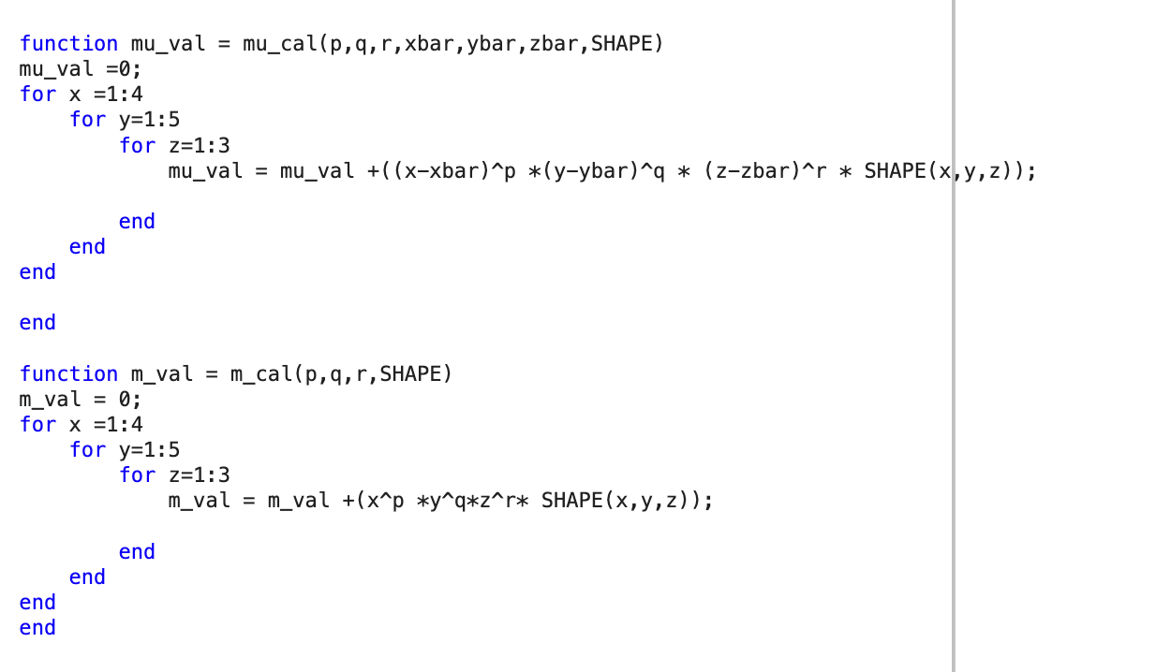I made 3 methods to calculate the u (mu_cal) and m (m_cal) values respectively.

mu_000 = 12

1. 

mu_200 = 2.916666666666667





mu_020 = 8





mu_002 = 6.916666666666666





J1 = 17.833333333333336

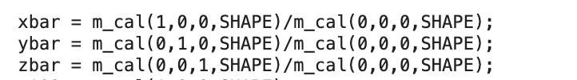



Xbar = 2.416666666666667

Ybar = 3

Zbar = 1.916666666666667

Hence, centroid = [2.416, 3, 1.916]

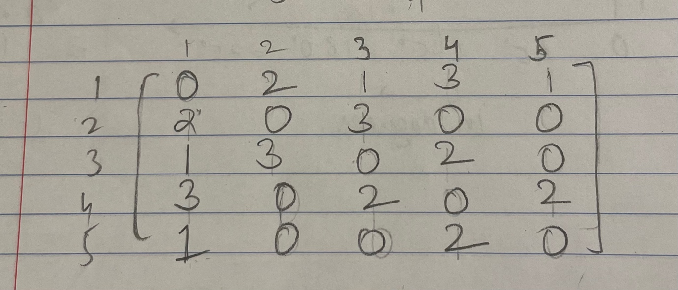PART 5



|  |  |
| --- | --- |
| Node | Degree |
| 1 | 4 |
| 2 | 2 |
| 3 | 3 |
| 4 | 3 |
| 5 | 2 |

1. 3 * Number to triangles / # pats with length 2

= 3 * 3/ 14 = 9/14

1. C1 = 3/6 = 1/2 , C2 = 2/3
2. # connections/ # possible connections = 7/(5*4/2) = 7/10
3. 